DAY 2 LAB

- Mini-Max Algorithm
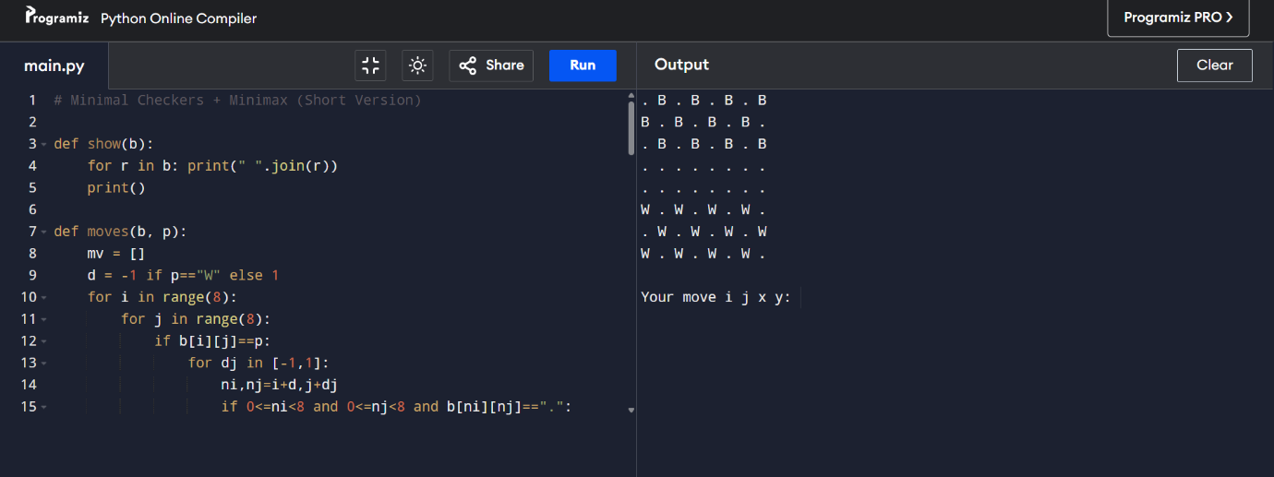

ALGORITHM:
- Represent the board as an 8×8 grid and define rules for legal moves (normal moves + jumps).
- Generate all possible moves for the current player by checking each piece and its allowed directions.
- Use Minimax with Alpha–Beta pruning to evaluate moves by exploring possible future board states.
- Choose the best move for the AI (maximizing score) and execute it on the board.
- Repeat until no moves are available and then declare winner based on remaining piece

- Tic-Tac-Toe
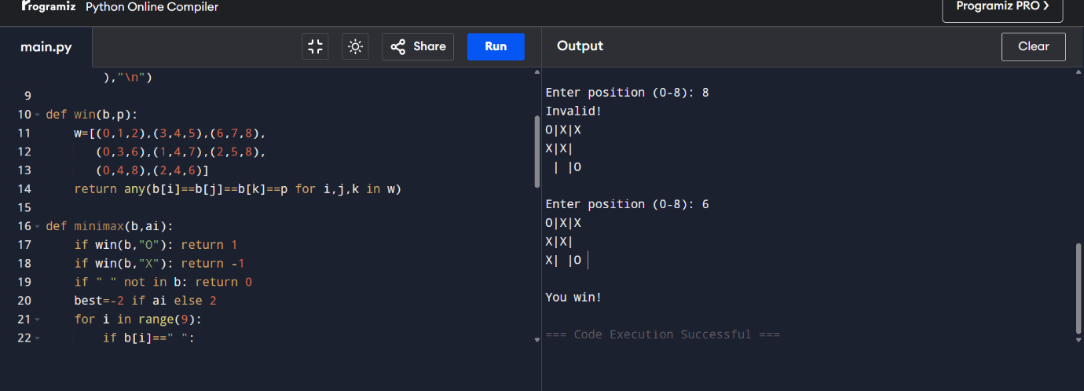

ALGORITHM:
- Initialize a 3×3 board with empty cells.
- Human enters a move; update board and print it.
- AI uses Minimax algorithm to evaluate all possible moves and select the one that leads to the best outcome.
- After every move, check for win or draw using all winning combinations.
- Continue alternating turns until X or O wins, or no spaces remain → draw.

- Vacuum Cleaner

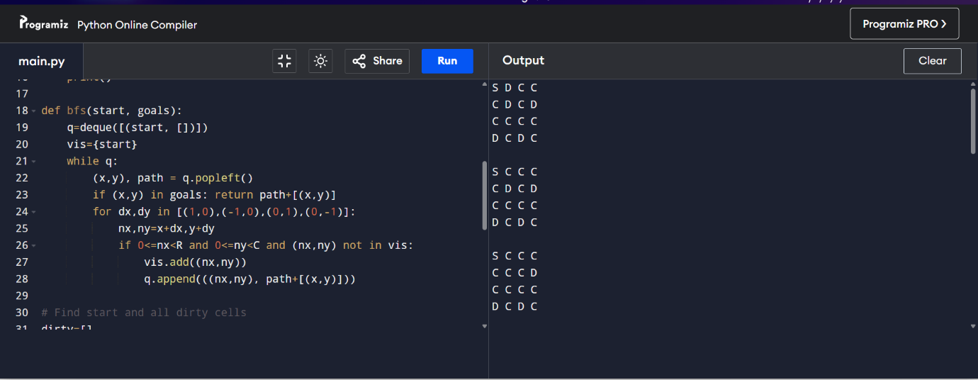

ALGORITHM:
- Represent the environment as a grid with clean and dirty cells and a starting position.
- Identify all dirty cells and locate the vacuum’s current position.
- Use BFS (Breadth-First Search) to find the shortest path to the nearest dirty cell.
- Move step-by-step along the path, cleaning the cell once the vacuum reaches it.
- Repeat BFS and cleaning until all dirty cells are cleaned, then stop.

